Perfect—let’s turn the AI requirements from the JD into a full enterprise system + architecture design you can confidently present in an interview.

🎯 Problem Statement (Derived from JD)
Design an Enterprise AI Platform that supports:
- Copilots (chat + workflow automation)
- RAG-based knowledge systems
- Agentic AI (multi-agent workflows)
- Context + memory optimization
- Governance, observability, cost control

🧱 1. High-Level Architecture
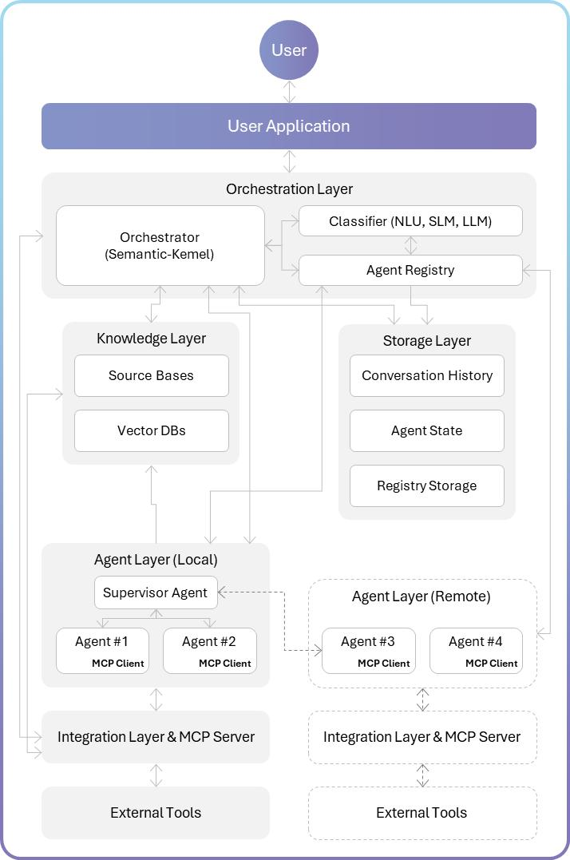
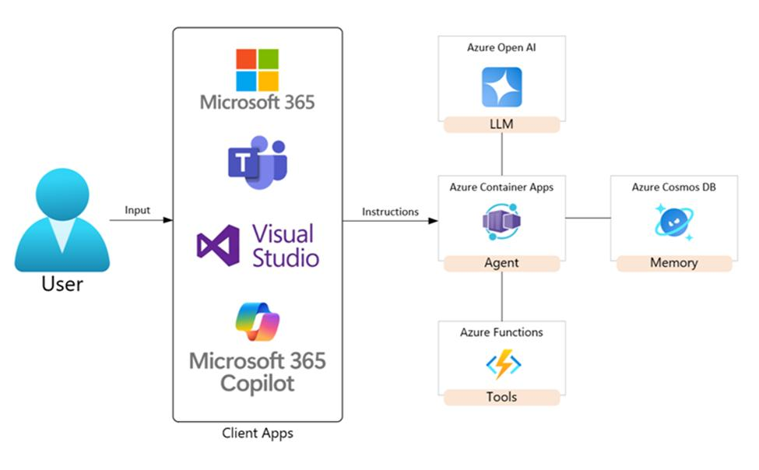
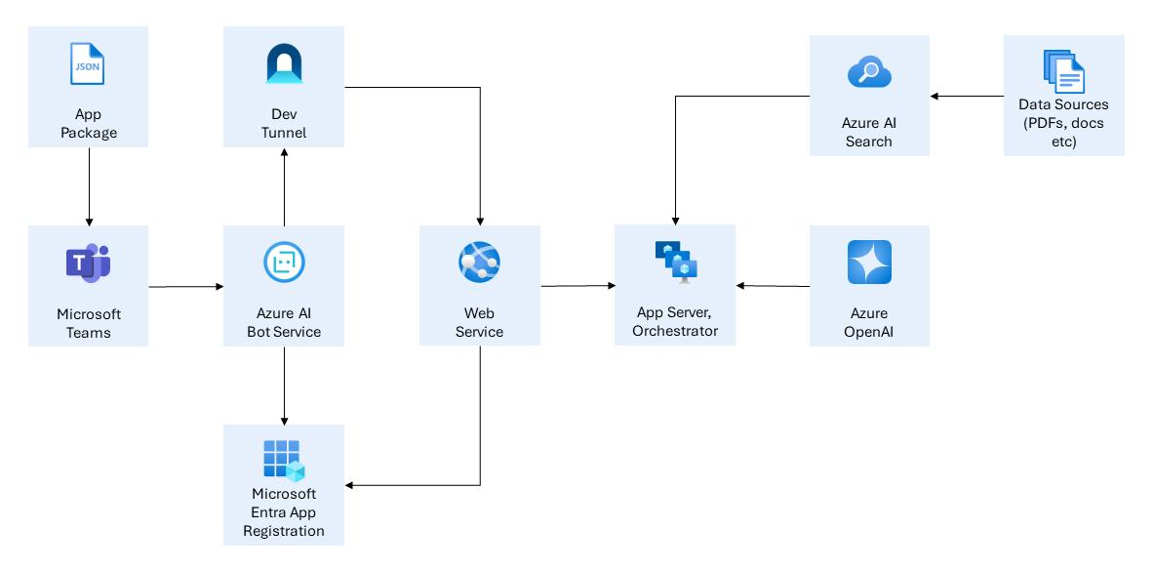
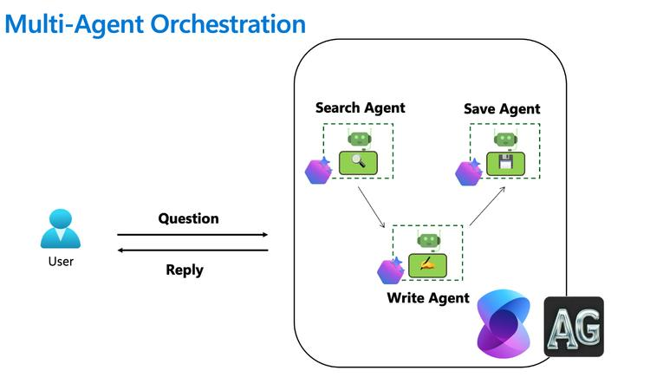
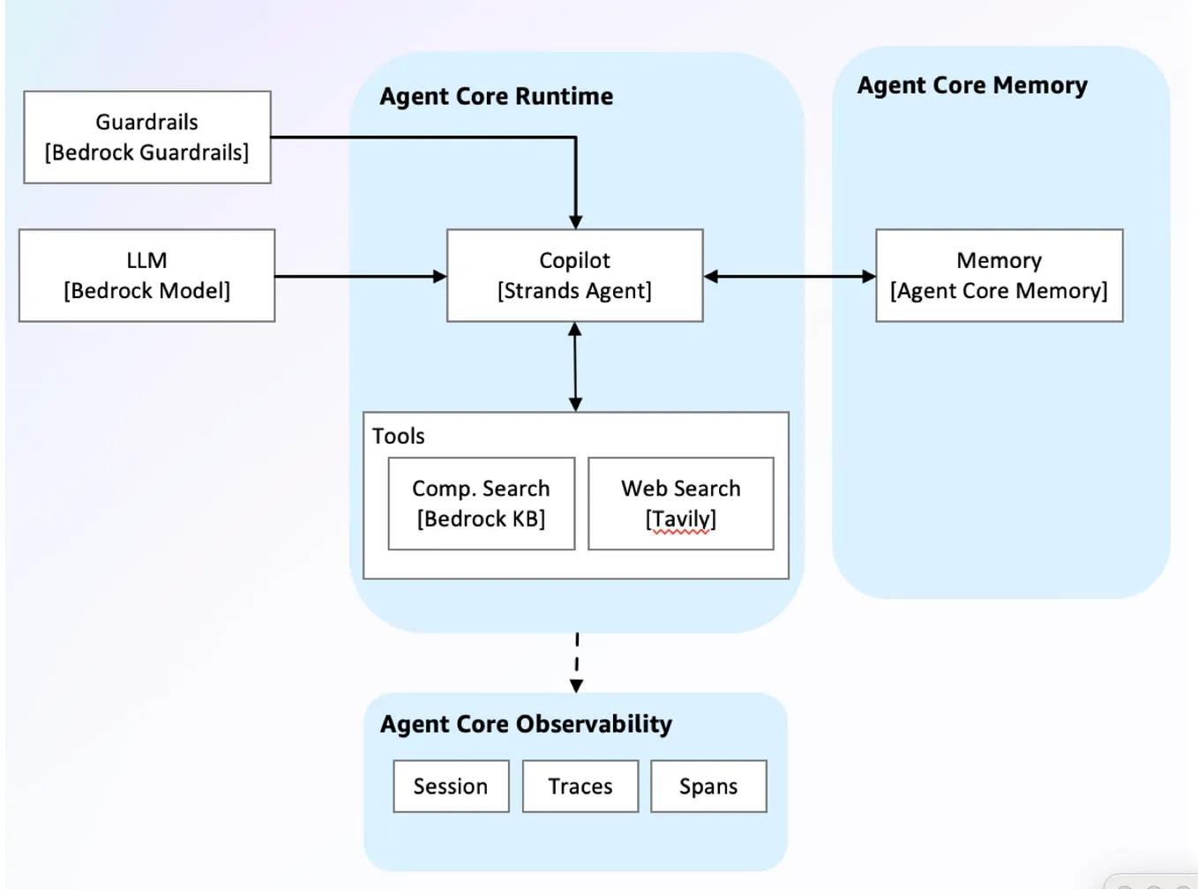
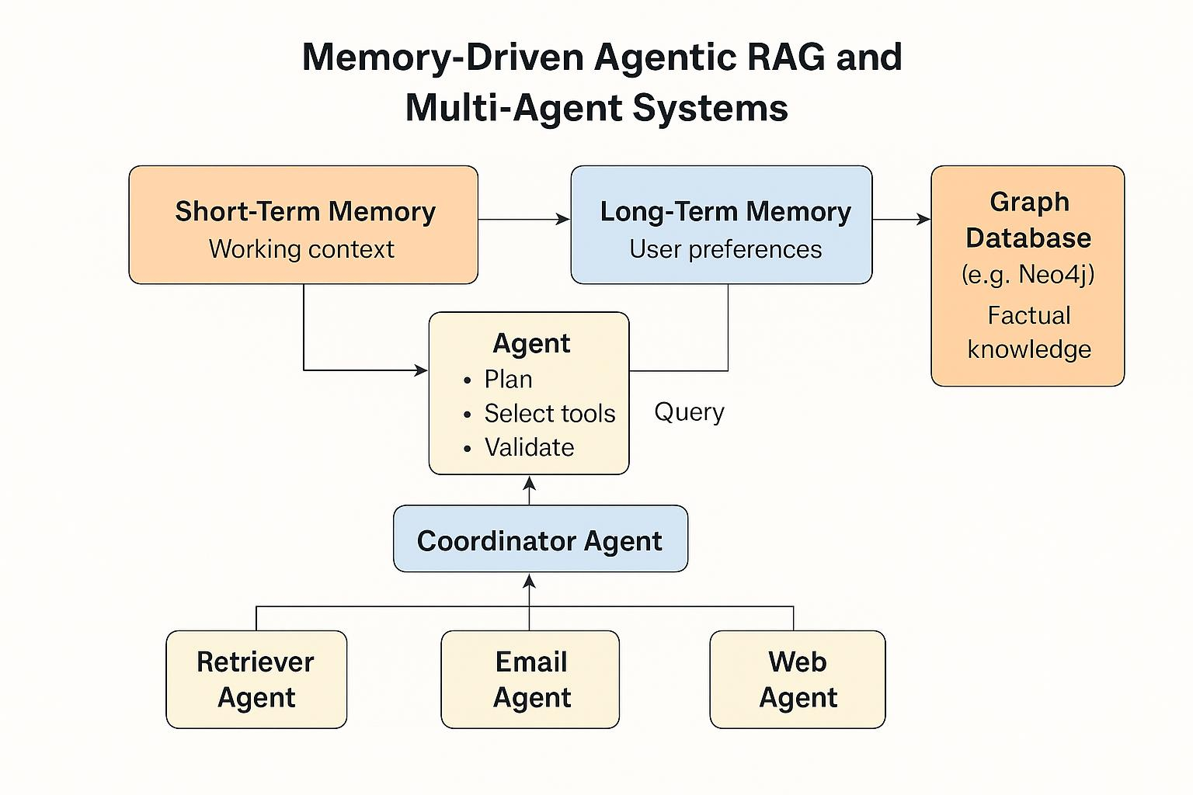
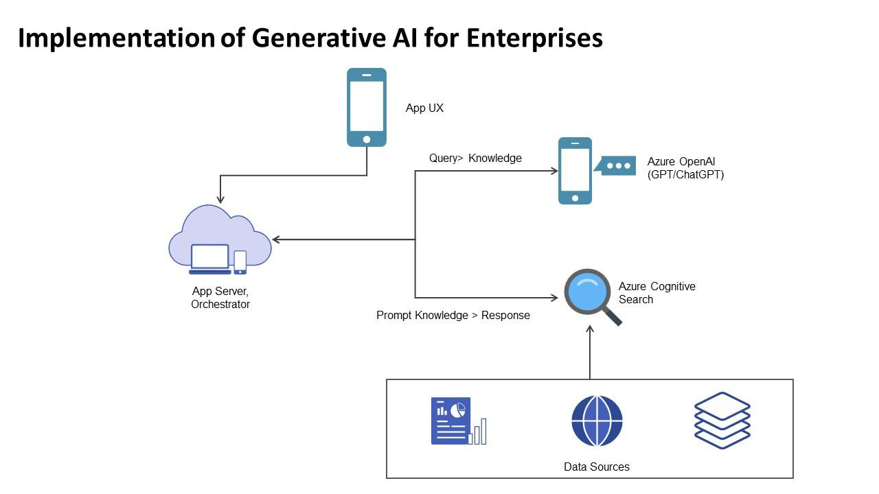

🔹 Core Layers

1. Experience Layer
- Web app / Teams bot / internal tools
- Copilot UI (chat + actions)

2. API Gateway Layer
- Auth, throttling, routing
- Entry point for all AI calls

3. Orchestration Layer (Brain)
👉 Most critical layer
- Agent orchestrator
- Workflow engine
- Prompt builder
- Context manager

4. AI Layer
- Azure OpenAI Service
- Embeddings
- Model routing (GPT-4 / smaller models)

5. Retrieval Layer (RAG)
- Azure AI Search
- Vector DB + semantic ranking

6. Memory Layer
- Short-term: Redis
- Long-term: Vector DB + DB

7. Data Layer
- Documents (Blob storage)
- Enterprise systems (APIs, DBs)

8. Governance & Observability
- Logging, tracing
- Cost tracking
- Audit

🧠 2. Core AI Architecture (JD Coverage)

🔹 A. LLM Integration Pipeline
User Query
↓
Intent Detection
↓
Context Builder
↓
Prompt Template Engine
↓
LLM Call
↓
Response Formatter

Key Capabilities
Capability | Implementation
Prompt engineering | Template-based prompts
Context optimization | Token budgeting + filtering
Grounding | RAG + citations
Output control | JSON / structured outputs

🔹 B. RAG Architecture (Grounding)
Document Ingestion
↓
Chunking (300 tokens)
↓
Embedding
↓
Vector Storage
↓
Query → Top-K Retrieval
↓
Re-ranking
↓
Context Injection into LLM

Design Decisions
- Hybrid search (keyword + vector)
- Top-K = 3–5
- Chunk overlap = 10–20%

🔹 C. Context Window Optimization
Context Builder:
- Top-K chunks
- Memory summary
- User query

Token Budget Enforcer:
- max tokens per section

Example Budget
Section | Tokens
System | 300
Context | 2500
Memory | 500
Query | 200

🤖 3. Agentic AI Architecture
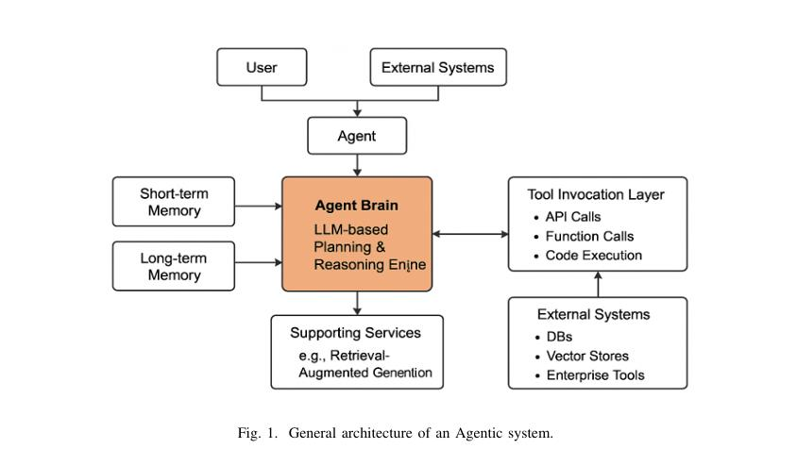
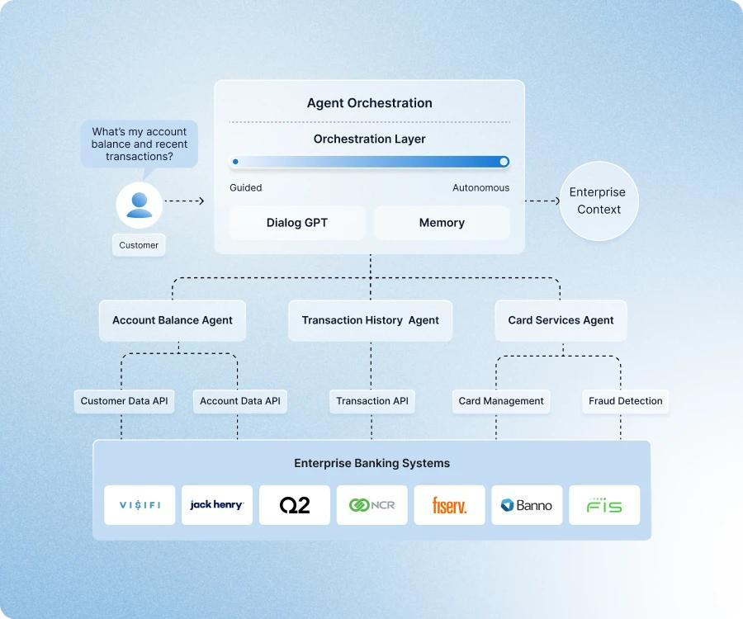
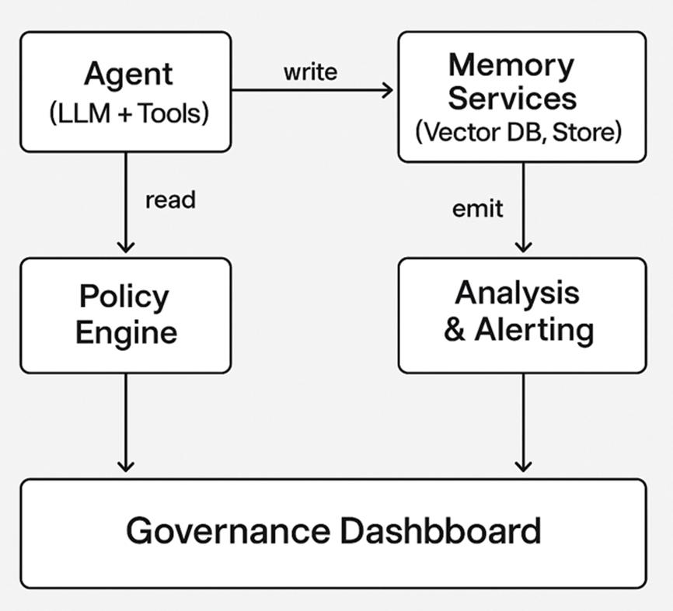
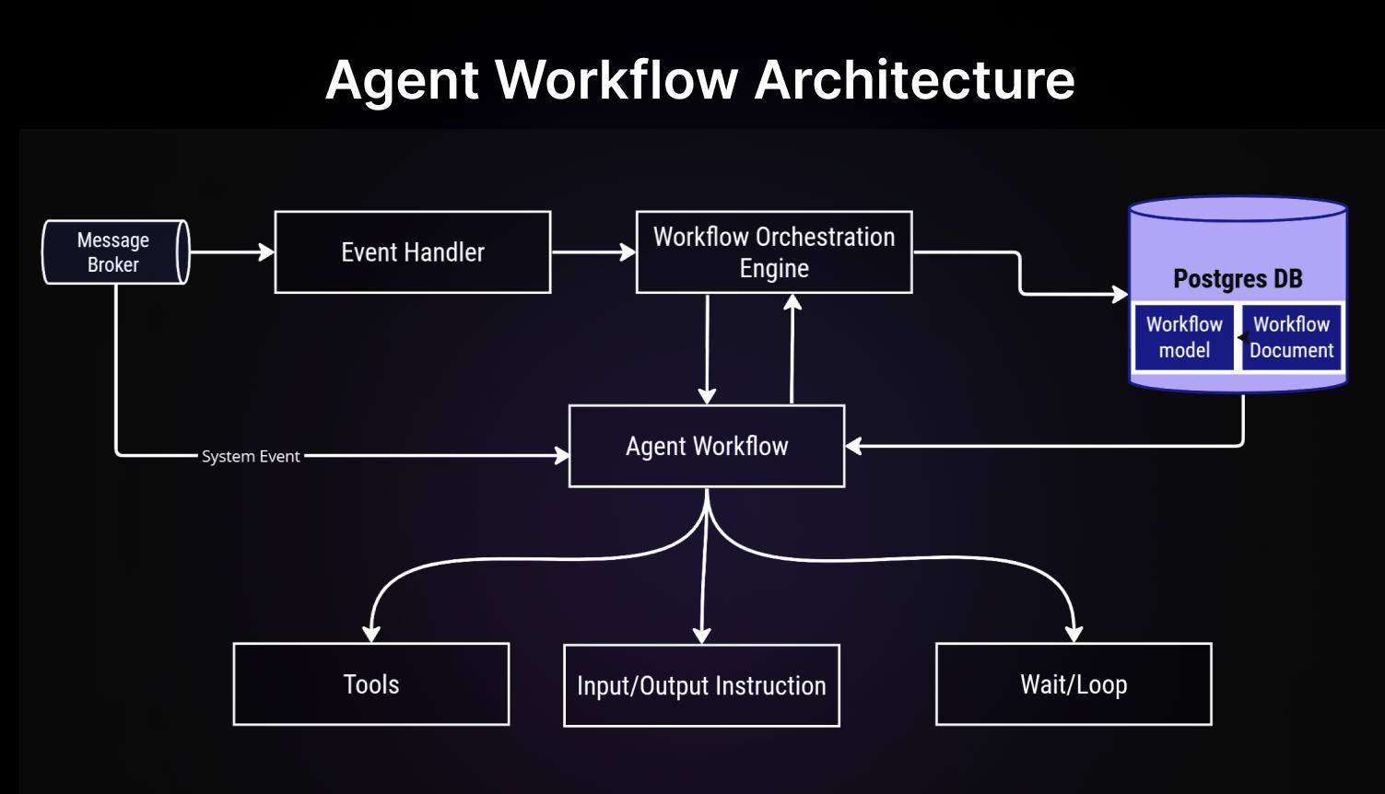
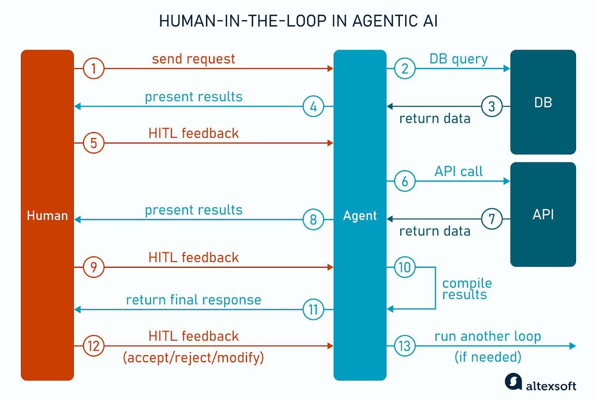
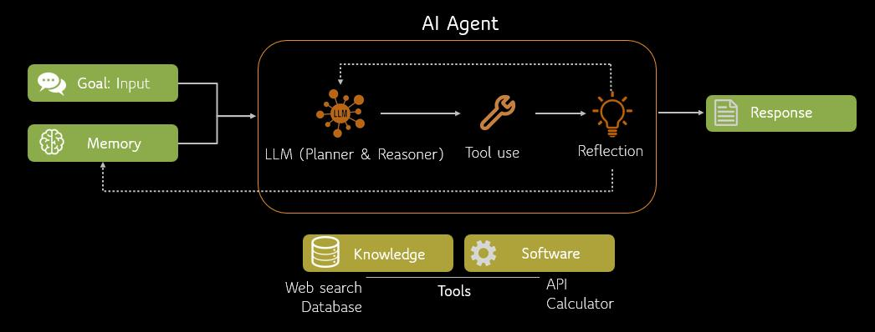

🔹 Agent Types
Agent | Responsibility
Planner | Breaks task into steps
Retriever | Fetches data
Executor | Calls APIs/tools
Validator | Checks rules/compliance
Responder | Final answer

🔹 Orchestration Flow
User Query
↓
Planner Agent
↓
Task Decomposition
↓
Executor + Retriever Agents
↓
Validator Agent
↓
Final Response

🔹 Tool Integration
Agents can call:
- REST APIs
- Databases
- External services
👉 Example:
- “Approve loan” → call loan API + policy validation

🧠 4. Memory Architecture

🔹 Memory Types
Type | Storage | Purpose
Short-term | Cache (Redis) | recent context
Long-term | Vector DB | past interactions
Semantic | Search index | knowledge base
Episodic | DB | history/logs

🔹 Memory Flow
Retrieve Memory
↓
Summarize
↓
Inject into Context
↓
Update Memory after Response

🔹 Rules
- Store only important info
- Periodically summarize
- Apply TTL

🔐 5. Responsible AI + Governance

🔹 Controls
- PII masking
- Role-based access
- Prompt filtering
- Output validation

🔹 Audit
- Prompt logs
- Response logs
- User actions

📊 6. Observability & Cost Optimization

🔹 Observability
Track:
- latency
- token usage
- error rates
- hallucination rate

🔹 Cost Optimization
- Token limits
- Caching responses
- Model selection (small vs large)

⚙️ 7. AI-First Delivery (How You Implement)

🔹 Development
Using GitHub Copilot:
- Code generation
- Test generation
- Infra scripts

🔹 CI/CD
- Automated pipelines
- AI-assisted debugging

🔹 Accelerators
- RAG framework
- Agent orchestration SDK
- Prompt libraries

🎯 8. End-to-End Flow (Put Everything Together)
User Query
↓
API Gateway
↓
Orchestrator
↓
Intent Detection
↓
Memory Retrieval
↓
RAG Retrieval
↓
Context Optimization
↓
Agent Orchestration (if needed)
↓
LLM Call
↓
Response
↓
Memory Update + Logging

💡 Final Interview Positioning
If you explain this architecture clearly, you demonstrate:
✅ LLM integration mastery
✅ RAG + context optimization
✅ Agentic AI design
✅ Enterprise readiness (governance, cost, observability)

🚀 If you want next level
I can:
- Convert this into a clean architecture diagram (PowerPoint-ready)
- Give .NET + Azure implementation blueprint
- Or run a live system design mock interview where I challenge your decisions

